BSCS FINAL PROJECT

FWEC MANAGER



Project Advisor

Usama Pervaiz

Presented by:
Group ID: S23BS029

Student Reg#
L1F19BSCS0469
L1F19BSCS0549
L1F17BSCS0570
Student Name
Muhamad Abdul Mueed
Muhammad Saad
Momin Khan

Faculty of Information Technology

University of Central Punjab
Software Requirements Specification
Version <Version 1>

FWEC Manager
Advisor
USAMA PERVAIZ
Group <Group ID>
Member Name | Primary Responsibility
L1F19BSCS0469 | Equivalent work
L1F17BSCS0570 | Equivalent work
L1F19BSCS0549 | Equivalent work

Table of Contents
Table of Contents i
Revision History ii
Abstract iii
1. Introduction and Background 1
1.1 Product (Problem Statement) 1
1.2 Background 1
1.3 Scope 1
1.4 Objective(s)/Aim(s)/Target(s) 1
1.5 Challenges 1
1.6 Learning Outcomes 1
1.7 Nature of End Product 1
1.8 Completeness Criteria 1
1.9 Business Goals 1
1.10 Related Work/ Literature Survey/ Literature Review 2
1.11 Document Conventions 2
2. Overall Description 3
2.1 Product Features 3
2.2 User Classes and Characteristics 3
2.3 Operating Environment 3
2.4 Design and Implementation Constraints 3
2.5 Assumptions and Dependencies 3
3. Functional Requirements 4
3.1 Name of Use-Case 1 4
3.2 Name of Use-Case 2 (and so on) 4
3.3 Requirements Analysis and Modeling 4
4. Nonfunctional Requirements 5
4.1 Performance Requirements 5
4.2 Safety Requirements 5
4.3 Security Requirements 5
4.4 Additional Software Quality Attributes 5
5. Other Requirements 5
6. Revised Project Plan 5
7. References 6
Appendix A: Glossary 7
Appendix B: IV & V Report 8

Revision History
Name | Date | Reason For Changes | Version

Abstract
In order to streamline operations and provide convenience to the forest department, a comprehensive online system has been developed to digitize paperwork and facilitate various aspects related to wildlife, forests, environment and climate. This system aims to raise awareness among the public about these crucial issues while also enabling them to contribute through donations. Additionally, client details are securely stored for efficient management. The system incorporates climate change awareness initiatives specific to our country and establishes an online store for the sale of goods and items related to wildlife, forests, environment, and climate. Furthermore, it offers an easy-to-use platform for wildlife management, where animal details are stored and relevant laws are publicly accessible through the website. This integrated system serves as an efficient tool to enhance public engagement, protect wildlife, preserve forests, conserve the environment, combat climate change, and ensure transparency in governance.

Introduction and Background

Product (Problem Statement)
Our website shifts all paper work into online ear. we are creating this product for climate awareness, online store for forest items and collecting donation

Background
Introducing our comprehensive online system designed to streamline forest department operations and promote environmental conservation. Our platform digitizes paperwork, raises awareness about wildlife, forests, environment, and climate, facilitates donations, stores client details securely, provides climate change updates, offers an online store for related goods, and simplifies wildlife management. Join us in creating a sustainable future by engaging the public, protecting wildlife, preserving forests, combatting climate change, and ensuring transparency in governance.

Scope

The comprehensive online system covers a wide range of functionalities, including digitizing paperwork, raising public awareness about wildlife, forests, environment, and climate, facilitating donations, securely storing client details, providing climate change updates, establishing an online store for related goods, and offering a user-friendly platform for wildlife management. The system aims to enhance public engagement, protect wildlife, preserve forests, promote environmental conservation, combat climate change, and ensure transparency in governance.

Objective(s)/Aim(s)/Target(s)

1. Digitize paperwork and eliminate manual processes, ensuring streamlined operations for the forest department.

2. Raise public awareness about wildlife, forests, environment, and climate-related issues through accessible and informative resources.

3. Enable the public to contribute to conservation efforts by providing a platform for donations.

4. Securely store and manage client details to enhance communication and personalized engagement.

5. Provide climate change awareness initiatives specific to our country, offering real-time updates and mitigation strategies.

6. Establish an online store to sell goods and items related to wildlife, forests, environment, and climate, promoting sustainable consumption.

7. Develop an easy-to-use platform for wildlife management, storing comprehensive details of animals for efficient monitoring and conservation.

8. Make relevant wildlife-related laws and regulations publicly accessible through the website, ensuring transparency and compliance.

9. Enhance public engagement and participation in wildlife conservation and environmental initiatives.

10. Protect wildlife by implementing effective management practices and promoting habitat preservation.

11. Preserve forests by implementing sustainable forestry practices and raising awareness about deforestation.

12. Conserve the environment by promoting eco-friendly practices and sustainable resource management.

13. Combat climate change by educating the public about its impacts and encouraging sustainable actions.

14. Ensure transparency in governance by providing public access to information and promoting accountability in wildlife management.

Challenges
1. Data security and privacy in storing client details.
2. Promoting awareness and engagement in remote or underprivileged areas.
3. Resistance to change from traditional paperwork to digital systems.
4. Developing user-friendly interfaces for the online store and wildlife management platform.
5. Providing accurate and up-to-date information on climate change.
6. Effective marketing strategies for driving sales and generating donations.
8. Compliance with wildlife protection and online sales regulations.
9. Scalability to accommodate increasing user traffic and data storage.

Learning Outcomes
- Complete command of frontend and backend.
  - Expert of JavaScript.
  - Learn the framework of python.

Nature of End Product
A website having a complete package to provide services

Completeness Criteria
S.No. | Criteria | Weightage %
1 | Desktop GUI | 20
2 | Web Application Development | 40
3 | Algorithm Development | 10
4 | Database development | 10
5 | Testing | 10
6 | Presentation, User & developer Manual | 10

Business Goals

Streamline operations, raise public awareness, facilitate fundraising, enhance wildlife management, generate revenue through the online store.

Related Work/ Literature Survey/ Literature Review

Several existing systems and initiatives are relevant to the goals and functionalities of the proposed system. These include:

1. Wildlife Conservation Platforms: Various online platforms exist that focus on wildlife conservation, providing information, awareness campaigns, and donation opportunities to support conservation efforts.

2. Environmental Awareness Websites: Websites dedicated to raising awareness about environmental issues, climate change, and sustainable practices already exist, offering educational resources and advocacy opportunities.

By examining and learning from these existing systems, the proposed system can leverage best practices, identify potential challenges, and ensure that it offers unique features and benefits to its users and stakeholders.

Document Conventions
The document is prepared using Microsoft Word 2021 using the font style ‘Times new romen’. The fixed font size used to type this document is 12 font size, with the heading being 14. It has used the bold property to set the heading of the document

Overall Description

Product Features
1. Paperwork Digitization: The system digitizes paperwork, eliminating manual documentation and streamlining operations for the forest department.

2. Awareness and Education: The system raises public awareness about wildlife, forests, environment, and climate through educational resources and interactive content.

3. Donation Management: Users can contribute to conservation efforts by making donations through the system, supporting wildlife, forests, environment, and climate initiatives.

4. Secure Client Management: Client details are securely stored for efficient management and communication with individuals interested in wildlife and environmental matters.

5. Climate Change Awareness: The system incorporates country-specific climate change initiatives, providing up-to-date information and promoting understanding of climate-related challenges.

6. Online Store: An online store within the system allows users to purchase goods and items related to wildlife, forests, environment, and climate.

7. Wildlife Management Platform: The system offers an easy-to-use platform for wildlife management, storing animal details and ensuring compliance with relevant laws.

8. Public Accessibility of Laws: Relevant wildlife-related laws are made publicly accessible through the system's website, promoting transparency and awareness of legal regulations

User Classes and Characteristics
• User
• Users use the web application and make donations and use other resources.
• Admin
• Developers of Web application or other trained person.

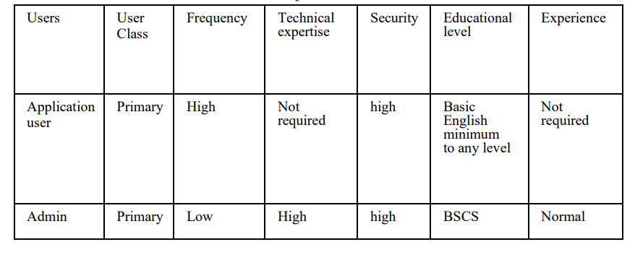

.

Operating Environment
- It is a web-based software which will be operated on web brewers.
- Front end HTML and CSS
- And backend in python and JavaScript
- Database in MYSQL

Design and Implementation Constraints
- The system shall use a MySQL database. Databases should be protected.

- The system should be a Web-based application.

- The system is only accessible within the Pakistan premises only

- Only Administrator and users authorized by the administrator can make changes in the system.

Assumptions and Dependencies
Assumptions:
- Users have basic computer skills and internet access.
- The forest department has reliable internet connectivity and necessary infrastructure.
- The forest department can maintain and support the system.
- Public is willing to engage and contribute to wildlife conservation.
- Laws and regulations are provided accurately for public dissemination.

Dependencies:
- Availability and reliability of internet services and infrastructure.
- Accuracy and availability of wildlife and environmental information.
- Integration with third-party payment gateways.
- Compliance with data protection and privacy regulations.
- Active participation and interest from the public and stakeholders.

Functional Requirements
- It is assumed that server and required services are running for the system to work

- It is assumed that the developers will have enough training to take care of the system if any sort of problem occurs in the future.

User Registration
Identifier |  | UC-001
Purpose |  | To allow users to create an account and access the features of the website.
Priority |  | High
Pre-conditions |  | The user is on the website registration page
Post-conditions |  | The user successfully registers an account.
Typical Course of Action
S# | Actor Action |  | System Response
1 | User enters their personal information. |  | The system validates the entered information.
2 | User selects a username and password. |  | The system validates the entered information.
3 | User agrees to the terms and conditions. |  | The system displays a confirmation message to the user.
…
Alternate Course of Action
S# | Actor Action |  | System Response
1
2
3
…
Table 1: UC-1

Wildlife Information Search
Identifier |  | UC-002
Purpose |  | To enable users to search for information about wildlife species.
Priority |  | Medium
Pre-conditions |  | The user is logged into the website.
Post-conditions |  | The user receives search results with relevant wildlife information.
Typical Course of Action
S# | Actor Action |  | System Response
1 | User enters the search keywords or selects a specific wildlife category. |  | The system processes the search query.
2 | User submits the search query.  . |  | The system retrieves relevant wildlife information from the database. And The system displays search results to the user.
Alternate Course of Action
S# | Actor Action |  | System Response
1
2
3
…

3.3 Donation Submission

Identifier |  | UC-003
Purpose |  | To allow users to make donations to support wildlife, forests, environment, and climate initiatives.
Priority |  | High
Pre-conditions |  | The user is logged into the website and on the donation page.
Post-conditions |  | The user successfully submits a donation.
Typical Course of Action
S# | Actor Action |  | System Response
1 | User selects the donation amount. |  | The system processes the donation request.
2 | User chooses the cause or project for the donation. |  | The system securely handles the payment transaction
3 | User provides payment information. |  | The system sends a confirmation email to the user
4 | User confirms the donation.
Alternate Course of Action
S# | Actor Action |  | System Response
1
2
3

3.4 Wildlife Sightings Reporting

Identifier |  | UC-004
Purpose |  | To enable users to report wildlife sightings for conservation purposes.
Priority |  | Medium
Pre-conditions |  | The user is logged into the website.
Post-conditions |  | The wildlife sighting report is submitted.
Typical Course of Action
S# | Actor Action |  | System Response
1 | User provides details of the wildlife sighting (species, location, date, etc.). |  | The system validates the provided information.
2 | User uploads any supporting media (photos, videos, etc.). |  | The system saves the wildlife sighting report in the database.
3 | User submits the wildlife sighting report. |  | .  The system sends a confirmation message to the user.
…
Alternate Course of Action
S# | Actor Action |  | System Response
1
2
3
…

Use Case Diagrams:
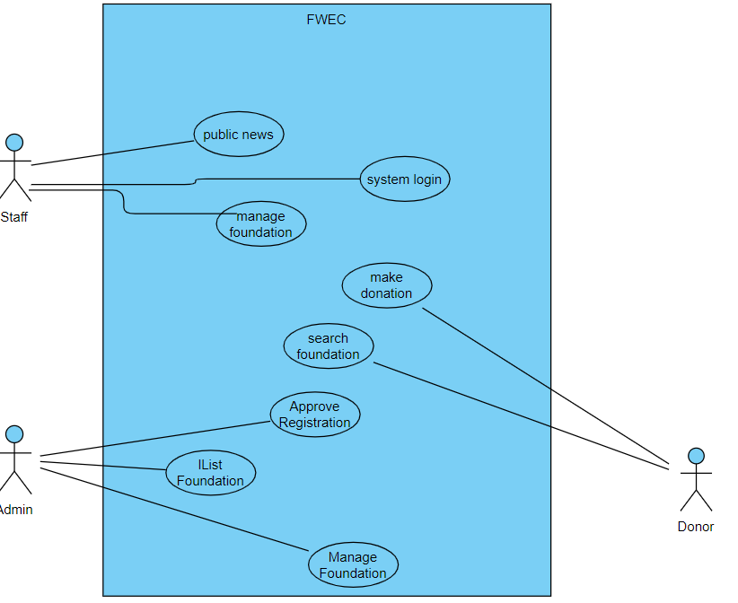
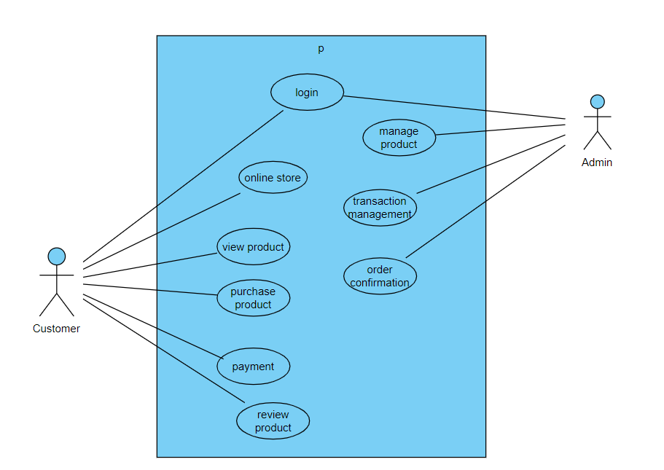
3.5 Online Store Purchase

Identifier |  | UC-005
Purpose |  | Purpose: To enable users to purchase goods and items related to wildlife, forests, environment, and climate
Priority |  | High
Pre-conditions |  | The user is logged into the website and on the online store page
Post-conditions |  | The user successfully completes a purchase.
Typical Course of Action
S# | Actor Action |  | System Response
1 | User browses the available products. |  | The system calculates the total order amount.
2 | User selects the desired product(s) and adds them to the shopping cart. |  | The system securely handles the payment transaction.
3 | User provides shipping and payment information |  | The system processes the order and generates an order confirmation.
… | User confirms the purchase. |  | The system updates the inventory and sends an order confirmation to the user.
Alternate Course of Action
S# | Actor Action |  | System Response
1
2
3
…

ERD Diagram:
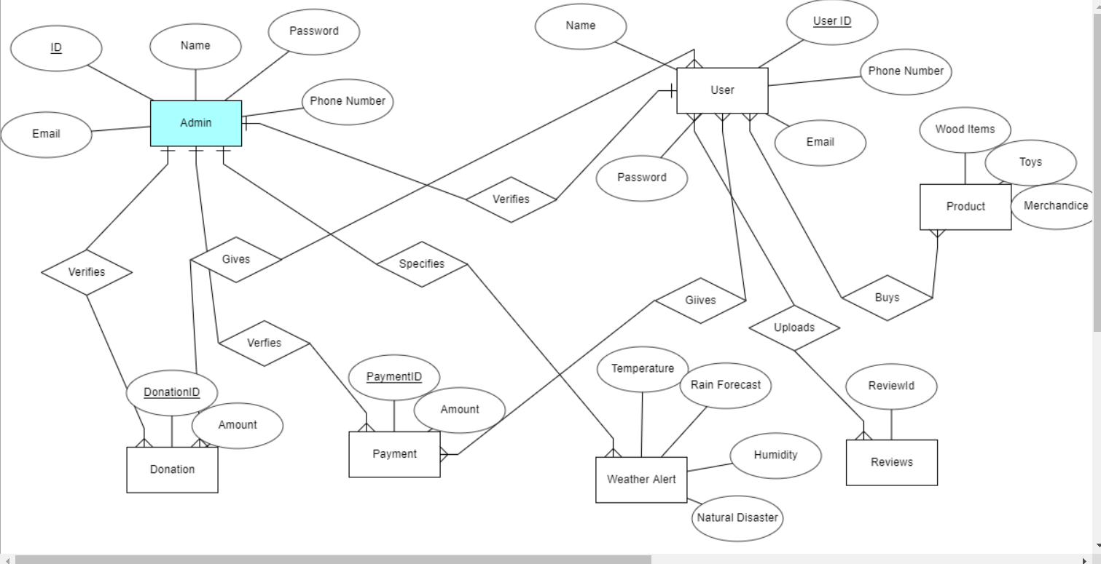

Class Diagram:

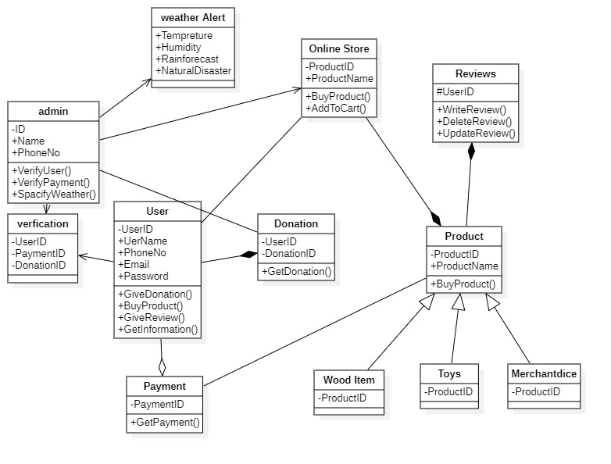

Nonfunctional Requiremen

Performance Requirements
- Response Time: The system should respond to user actions within 2 seconds for optimal user experience.
- System Availability: The system should have a minimum uptime of 99.9% to ensure uninterrupted access.
- Throughput: The system should support a minimum of 100 simultaneous user sessions to handle user demand.
- Database Performance: Database queries should execute and return results within 1 second for efficient data retrieval.
- Security and Data Protection: The system should ensure secure transmission and storage of user data, complying with relevant data protection regulations.

Safety Requirements

- User Data Protection: Ensure secure storage and transmission of user data.
- System Security: Implement measures to prevent unauthorized access and data breaches.
- Compliance with Regulations: Adhere to data protection and privacy laws.
- Error Handling: Promptly detect and handle errors or exceptions.

These safety requirements focus on protecting user data, ensuring system security, complying with regulations, and maintaining effective error handling mechanisms.

Security Requirements

The system should implement strong user authentication, data encryption for confidentiality, access control to restrict unauthorized access, secure communication protocols, logging and auditing for monitoring, proactive vulnerability management, and an incident response plan. These measures aim to safeguard user information, ensure secure system access, protect data during transmission and storage, and mitigate potential security risks.

Additional Software Quality Attributes
- Usability: The system should be user-friendly and intuitive, allowing users to easily navigate and interact with its features and functionalities.

- These software quality attributes focus on the reliability, usability, scalability, maintainability, and portability of the system, ensuring a high-quality and efficient software solution.

Other Requirements
N/A

Revised Project Plan
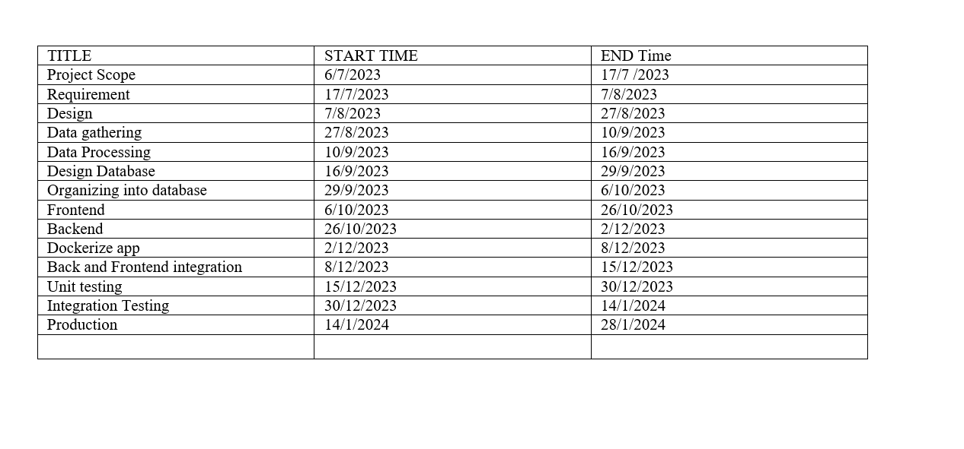

References
US WILD LIFE

Appendix A: Glossary
N/A
Appendix B: IV & V Report
(Independent verification & validation)
IV & V Resource

Name Signature

S# | Defect Description | Origin Stage | Status | Fix Time
 |  |  |  | Hours | Minutes
1
2
3
…
Table 2: List of non-trivial defects

